The Holocaust
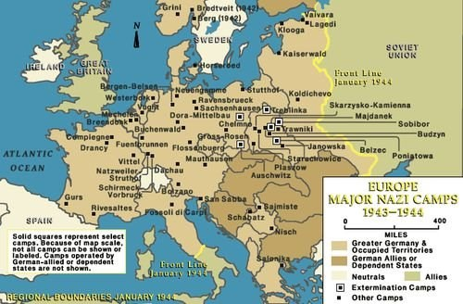
The Holocaust refers to the horrific time period from 1933 to 1945 when throughout Europe over six million Jewish men, women, and children were systematically killed by the Nazi government of Germany. This period is one of the most tragic chapters in human history. The Nazi government perceived the Jewish people as an inferior race and a threat to humanity. As a result, the Nazi government, led by Adolph Hitler, organized the mass murder of Jewish people. Their ultimate goal was to kill all Jewish people.
Hitler became chancellor of Germany in 1933, representing the Nazi Party. He hated Jewish people. Soon after he became chancellor, the Nazi government made laws to limit the freedoms of Jewish people. The government also distributed anti-Semitic, or anti -Jewish, propaganda to the German people. Hitler wanted a country of all white citizens. He thought that white people were superior to other ethnicities. He believed the Jewish people were not only a religious group; he defined them as a race. Hitler claimed that the Jewish people were a disease to humanity.
The phrase, "The Jewish Question" referred to the question of the role of the Jewish people in society. The Nazi government looked to its own anti-Semitic policies as an answer. The Nazis developed a plan for the extermination of all Jewish people. They called it "The Final Solution to the Jewish Question."
During World War II, the Nazis rounded up Jewish people who were still in Germany and Nazi-controlled territories. Some had already left or were in hiding, but many had decided to stay or had nowhere to go. Allies of Nazi Germany, including Italy and the unoccupied part of France, also rounded up Jewish people. This was one of the ways they contributed to the Nazi agenda.
The Jewish people rounded up by the Nazis and their allies were sent to concentration camps. Most of the Jewish people were sent immediately to camps known as extermination camps, or death camps. The purpose of extermination camps was to kill all the people sent there. Some of the Jewish people were sent to labor camps. The people sent to the labor camps were treated inhumanely and forced to work hard hours. Many died because of the extremely harsh conditions or because of disease. Jewish people who were first sent to labor camps would often be sent to extermination camps as a final destination.
By the middle of 1942, news about "The Final Solution" reached the Allied governments, including the American and British governments, but they were slow to act in response. Critics say that the governments did too little to save the Jewish people. United States President Franklin D. Roosevelt thought that the best method to stop the killings was to defeat the Nazis as quickly as possible. He focused on creating military strategies that would defeat the Nazis as opposed to establishing plans for directly saving the Jewish people. The American government as well as the European governments that made up the Allied governments have been condemned for not doing enough to protect the Jewish people from the cruelty of the Nazi government.
As more and more people found out about the full scope of the Holocaust, they were shocked and horrified. How could over six million people, in the modern world, be killed for no reason other than their ethnicity, or cultural background? It is important to remember the Holocaust and to study what happened. Only by understanding this bleak part of history can we hope to prevent such horror from happening again.

The Holocaust - Comprehension Questions

Name: ___________________________________ Date: _______________
- How many Jewish men, women, and children were killed during World War II?
  - about six hundred
  - over six million
  - over sixty million
  - less than six thousand
- What does the text describe?
  - the cultural impact of the Jewish people throughout Europe
  - key events that led to World War II
  - Hitler's rise to political power
  - the Nazi government's efforts to exterminate the Jewish people
- Hitler hated Jewish people. What evidence from the text best supports the conclusion?
  - Hitler believed that the Jewish people were not only a religious group but also arace.
  - Hitler claimed that the Jewish people were a disease to humanity.
  - Hitler became chancellor of Germany in 1933, representing the Nazi party.
  - People were horrified when they found out about the full scope of the Holocaust.
- "The Jewish Question" referred to the question of the role of the Jewish people in society. What was the Nazi government's answer to this question?
  - increase the role of the Jewish people in society
  - eliminate the Jewish people from society so that they have no role
  - limit the role of the Jewish people in society
  - expand the role of the Jewish people in different areas of society
- What is this text mostly about?
  - World War II
  - Hitler's political power
  - the Holocaust
  - the Nazi government
.
The Holocaust - Comprehension Questions
- How did the Nazi government plan to exterminate the Jewish people? Use evidence from the text to support your answer.
- Why might people have been horrified when they found out about the full scope of the Holocaust? Use evidence from the text to support your answer.
- Choose the answer that best completes the sentence.
Hitler thought that white people were superior to other ethnicities. ________, he wanted a country of all white citizens.
  - Therefore
  - However
  - On the other hand
  - Initially
- Vocabulary Word: inhumane: lacking compassion, pity, or kindness towards man; not fit for humans.
Use the vocabulary word in a sentence
World War Two - Introduction to WWII
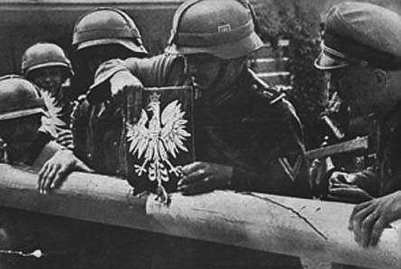
https://commons.wikimedia.org/wiki/File:Polish_border_1939.jpg
After World War I, Germany was defeated. The peace agreement that ended the war left the country humiliated but not crippled. In their humiliation, Germans looked for a powerful leader. Many Germans were dissatisfied with their government and wanted change. In the 1930's, a political group called the Nazi Party came to power.
A man named Adolf Hitler was the Fuhrer, or supreme leader of the Nazi Party. In 1933, Hitler was appointed chancellor of Germany. He became head of the German parliament. Hitler wanted power. He broke the World War I peace treaty and began to build an army. Hitler threatened the balance of peace all over Europe.
Meanwhile, two other countries were following Germany's lead. Powerful dictators in Italy and Japan were building up their own armies. Italy, Japan, and Germany would become the Axis Powers of World War II. Their hunger for military might was quite different from the U.S.'s desire for peace. The United States watched the other countries from a distance. People in the U.S. were worried, but they were isolationists. Americans did not want to get involved in another European war.
On September 1, 1939, Germany invaded Poland. World War II began. Britain and France were allies with Poland and declared war on Germany. Hitler's strategy was called blitzkrieg. This German word translates to "lightning war." The German army toppled countries before the countries knew what hit them. By June, Hitler had captured Paris, France.
For two years the United States tried to ignore the war. At the end of 1941, the U.S. was pulled into the war. The country was attacked by Japan. On December 8, 1941, the U.S. declared war on Japan. In return, Germany and Italy declared war on the United States. For the second time in 25 years, the world was fighting a global war.
The main Axis powers in World War II were Germany, Italy, and Japan. The biggest Allies were the U.S., Britain, France, and the U.S.S.R.
World War Two - Introduction to WWII - Comprehension Questions

Name: ___________________________________ Date: _______________
- According to the text, what did Germans look for after World War I?
  - a powerful leader
  - trade opportunities with the United States
  - peaceful ways to build relationships with other European countries
  - a different form of government
- The text describes the series of events that led to the outbreak of World War II and the involvement of the United States in World War II. What happened after the United States was attacked by Japan?
  - World War II began.
  - The U.S. declared war on Japan.
  - Italy and Japan built up their armies.
  - Hitler became chancellor of Germany.
- Read the following sentences from the text:
"On September 1, 1939, Germany invaded Poland. World War II began. Britain and France were allies with Poland and declared war on Germany. Hitler's strategy was called blitzkrieg. This German word translates to 'lightning war.' The German army toppled countries before the countries knew what hit them."
Based on this information, what can be concluded about the European countries Germany attacked?
  - They were prepared to defend themselves against Germany.
  - They wanted to make peace with Germany and support Hitler.
  - They were not prepared to defend themselves against Germany.
  - They were able to easily fight off Germany.
- How did Hitler seek power?
  - by making peace treaties with other countries
  - by creating a larger parliament for Germany
  - by taking over Japan and Italy
  - by building an army and defeating other countries

World War Two - Introduction to WWII - Comprehension Questions
- The passage is mostly about
  - Hitler's leadership
  - the relations among the Axis powers.
  - what led up to World War II
  - the United States' role in World War II
- According to the text, what did Hitler threaten?
- Based on the information in the text, was Hitler the type of leader Germany was looking for? Use evidence in the text to support your answer.
- Choose the answer that best completes the sentence.
People in the United States did not want to get involved in another European war.
________, when the country was attacked by Japan, it decided to enter World War II.
  - In summary
  - However
  - For example
  - For instance
- Vocabulary Word: humiliation: feeling of embarrassment or shame.
Use the vocabulary word in a sentence:
World War Two - Pearl Harbor
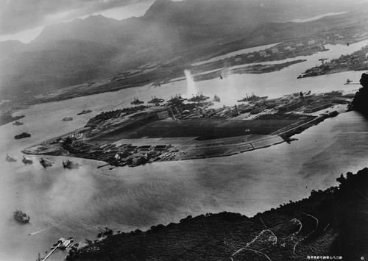
Pearl Harbor shortly after attack began, photo from Japanese plane
The United States stayed out of World War II until 1941. Early in the morning, on December 7, 1941, Japan attacked the U.S. naval base at Pearl Harbor. The attack was a complete surprise. Japanese planes torpedoed and bombed United States ships and military stations. By late morning the attack was over. Japan's planes left 2,403 Americans dead (including 68 civilians) and 1,178 military members and civilians wounded. There were 188 planes destroyed, 159 aircraft damaged, and 21 damaged or destroyed ships*.
When President Roosevelt found out about the attack, he asked Congress to declare war. The United States was behind him. Before the attack, the people of the U.S. had been divided over whether to help France and Great Britain fight Germany. Many people wanted to stay out of the war. People did not yet know about the horrors of Nazi concentration camps. But Japan's act of war changed the course of history. As a Japanese official said, "I am afraid that we have awakened a sleeping giant." Once moved to act, the U.S. was a giant. The U.S. came to Britain's aid and changed the outcome of the war.
President Roosevelt called the day of the attack "a day that will live in infamy." Below is the S.O.S. dispatch sent by the Commander in Chief of the Pacific Army, who was stationed at Pearl Harbor. He sent only:
"AIR RAID ON PEARL HARBOR X THIS IS NOT A DRILL."

World War Two - Pearl Harbor - Comprehension Questions

Name: ___________________________________ Date: _______________
- All of the following are true except:
  - The Japanese attack on Pearl Harbor was a surprise.
  - President Roosevelt wasn't sure what to do after the U.S. was attacked.
  - The U.S. joined forces with Britain.
  - The attack occurred on December 7, 1941.
- Before the attack,
  - President Roosevelt had attacked the Japanese.
  - the United States was fighting with Germany.
  - the U.S. population had been divided over whether to join the war.
  - the U.S. population had wanted to be part of the war.
- What kind of damage did the Japanese do to Pearl Harbor?
  - The attack damaged or destroyed 21 ships and killed 2,403 Americans.
  - The attack destroyed 188 Japanese planes.
  - The attack resulted in only a few casualties and slight damage.
  - The attack resulted in only a few casualties and slight damage.
- What caused the United States to enter World War II?
  - They were tired of Britain and France losing.
  - The United States wanted to assist Germany.
  - The United States was asked by the USSR to enter the war.
  - The Japanese attacked the United States without any warning.
- The passage is mostly about
  - concentration camps during World War II.
  - why harbors are important in war.
  - the Japanese alliance with Germany.
  - an attack on a U.S. military base and its consequences.
World War Two - Pearl Harbor - Comprehension Questions
- What did the Japanese official mean when he said, "I am afraid that we have awakened a sleeping giant"?
- What did President Roosevelt do once he heard about the attack on Pearl Harbor?
- The question below is an incomplete sentence. Choose the word that best completes the sentence.
The United States entered World War II ______ it was attacked by Japan.
  - although
  - first
  - secondD. after
- Vocabulary Word: infamy: being famous for something bad or evil.
Use the vocabulary word in a sentence:

World War Two - A Victory in Africa
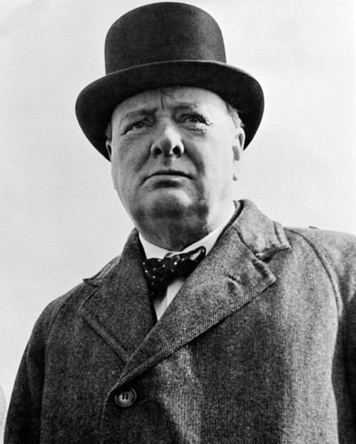
Winston Churchill, 1942
November 10, 1942

London
Last night, Winston Churchill spoke here in London at the Mansion House. His words warmed the hearts of all who listened. The Prime Minister brought the news of a great victory. The war in Africa may be ending. We can only hope that the German army will surrender in Europe as well. Day after day, the German air force drops bombs on our island. Our planes are outnumbered 2 to 1, but they still manage to defend us. The Royal Air Force is our greatest asset. But they cannot last alone forever. We need more victories on land. This new victory in Africa brings hope. Perhaps we have arrived at the turning point of this horrible World War. The following paragraphs are excerpts from the Prime Minister's Speech last night:
"In the last war we were uphill almost to the end. We met with continual disappointments and with disasters far more bloody than anything we have experienced so far in this. But in the end all oppositions fell together and our foes submitted themselves to our will.
"We have not so far in this war taken as many German prisoners as they have taken British, but these German prisoners will, no doubt, come in droves at the end, just as they did last time.
"I have never promised anything but blood, tears, toil and sweat. Now, however, we have a new experience. We have victory--a remarkable and definite victory. The bright gleam has caught the helmets of our soldiers and warmed and cheered all our hearts.
"It was a deadly battle. The Germans have been outmatched and outfought with every kind of weapon with which they had beaten down so many small peoples and, also, larger, unprepared peoples. They have been beaten by many of the technical apparatus on which they counted to gain domination of the world. Especially is this true in the air, as of tanks and of artillery, which has come back into its own. The Germans have received that measure of fire and steel which they have so often meted out to others.
"Now, this is not the end. It is not even the beginning to the end. But it is, perhaps, the end of the beginning."

World War Two - A Victory in Africa - Comprehension Questions

Name: ___________________________________ Date: _______________
- According to this passage, Winston Churchill's speech
  - warmed the hearts of all who listened.
  - discussed the disappointment of losing the war.
  - was extremely long and uninformative.
  - shared information about the United States.
- What do you think Winston Churchill meant when he said, "I have never promised anything but blood, tears, toil and sweat"?
  - He had expected the war to be easy.
  - He had expected the soldiers to cry.
  - He had expected the war to be difficult.
  - He had expected the war to be fun.
- What new experience had occurred?
  - There was a victory over Germany in Africa.
  - There was a loss to Germany in Africa.
  - The Japanese had attacked Germany.
  - Germany had declared an end to the war.
- The purpose of this speech was to
  - discuss the German victory.
  - give information and encouragement.
  - thank Japan for participating.
  - say goodbye to Winston Churchill.
- This passage is mostly about
  - a speech at an important point in a war.
  - Africa's war for its independence.
  - the speaking style of Winston Churchill.
  - the importance of airplanes in war.
- What were some factors that made the victory in Africa so exciting?
World War Two - A Victory in Africa - Comprehension Questions
- What is Winston Churchill's prediction about the number of German prisoners who will be captured?
- The question below is an incomplete sentence. Choose the word that best completes the sentence.
The victory in battle was important, _______ because it was a land battle.
  - spitefully
  - although
  - especially
  - tragically
- Vocabulary Word: excerpt: a part taken from a longer text.
Use the vocabulary word in a sentence:

World War Two - D-Day
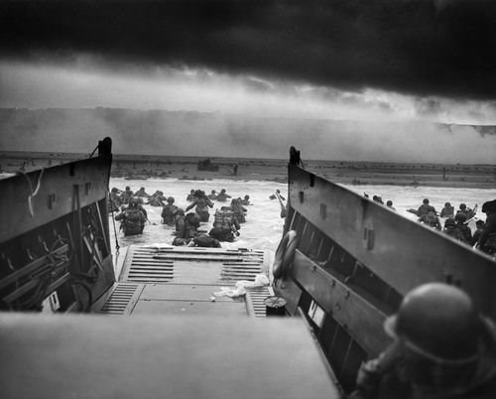
Chief Photographer's Mate Robert F. Sargent "Into the Jaws of Death"

May 30, 1944
Today we finally moved. The action has begun. For the past few months I have been in England. We have trained and studied. Now it is time to go. The code name for our movement is Operation Overlord. I do not know when we will strike the Germans. I do know that our ultimate hope, months from now, is to liberate Paris. But first, we need to get our foot in the door of Europe. I am afraid that Germany will slam the door in our face.
Germany now controls most of the continent. But we will win.

June 5, 1944
We have left Britain now. We are heading towards the coast of France. The English Channel is rough and choppy. Our ships rock back and forth. The air is foggy outside, but very few men go up on the deck of the ship anyway. We are all kept below to prepare for the fight. Most of the men are quiet and keep to themselves. We know that our job is necessary, but we also know that many of us will die. It is clear now that we will invade France on the beaches of Normandy. By morning, we will have landed. Who knows how long the fight will take, or who will survive... anything is possible for us, except defeat.
We will win.

June 6, 1944
Today was the hardest day of my life. But we are succeeding. Over 150,000 Allied troops and 5,000 ships landed together along the coast of Normandy. We fought the waves to reach the shore and fought for every inch of sand up to the hills. We had nowhere to retreat except to the cold ocean. Our only choice was to push forward and make the Germans move backward. I found out that our generals had staged an invasion in Calais. Thousands of rubber tanks landed - empty, of course - in that town far away from here. While the Germans tried to defend themselves against balloons, we stormed the beaches here. Thank goodness for the distraction. I cannot imagine what today would have been like with more German troops facing us.

August 1944
Paris is ours. Today Allied soldiers marched into Paris and liberated France. After four years of German occupation, Paris is finally free.

World War Two - D-Day - Comprehension Questions

Name: ___________________________________ Date: _______________
- This passage could be an example of which genre?
  - science fiction
  - mystery
  - historical fiction
  - fantasy
- Which of the following happened first?
  - "Paris is ours."
  - an invasion was staged in Calais
  - a few months of training in England
  - 3,000 ships landed on the beaches of Normandy
- The purpose of the staged invasion in Calais was to
  - distract the Germans.
  - assist the Japanese.
  - confuse the USSR.
  - help the Germans.
- Where did the soldiers invade France?
  - the beaches of Calais
  - the beaches of Normandy
  - the beaches of Germany
  - the beaches of Spain
- The passage is mostly about
  - the strategic reasons for attacking Normandy.
  - the best way to attack a beach.
  - a soldier's experience in World War II.
  - why soldiers refused to fight at Normandy.
- How would you describe the soldier who wrote this journal? Why?
World War Two - D-Day - Comprehension Questions
- Why did the soldiers train for months before the invasion?
- The question below is an incomplete sentence. Choose the word that best completes the sentence.
_______ the Allies took the beach at Normandy, they were able to liberate Paris.
  - During
  - Although
  - Without
  - Once
- Vocabulary Word: liberate: to set free.
Use the vocabulary word in a sentence:

