Name: ________________________
Date: _________________________
Period: _______________________

Treaty of Versailles-Picture Notes

Directions: Study each one of the political cartoons below very carefully. Then read each question listed beside each cartoon. Write your opinion of what the author/artist is trying to say about the particular subject.
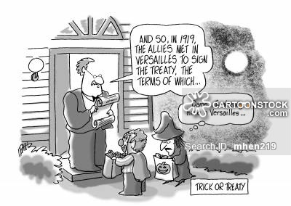

Look at the political cartoon depicted to the right. What do you think the author /artist is trying to say about the Treaty of Versailles?
_________________________________________________
_________________________________________________
_________________________________________________
_________________________________________________
_________________________________________________
_________________________________________________
_________________________________________________
_________________________________________________

Look at the political cartoon depicted to the left. What do you think the author/artist is trying to say about Germany and Reparations?
_________________________________________
_________________________________________
_________________________________________
_________________________________________
_________________________________________
_________________________________________
_________________________________________
_________________________________________
_________________________________________
