Document 1
Peace Treaty of Versailles (selected excerpts)
ARTICLE 45: As compensation for the destruction of the coal-mines in the north of France and as part payment towards the total reparation due from Germany for the damage resulting from the war, Germany cedes to France in full and absolute possession, with exclusive rights of exploitation, unencumbered and free from all debts and charges of any kind, the coal-mines situated in the Saar Basin as defined in Article 48.
ARTICLE 84: German nationals habitually resident in any of the territories recognised as forming part of the Czecho-Slovak State will obtain Czecho-Slovak nationality ipso facto and lose their German nationality.
ARTICLE 87: Germany, in conformity with the action already taken by the Allied and Associated Powers, recognises the complete independence of Poland, and renounces in her favour all rights and title over the territory bounded by the Baltic Sea…
ARTICLE 91: German nationals habitually resident in territories recognised as forming part of Poland will acquire Polish nationality ipso facto and will lose their German nationality…
ARTICLE 119: Germany renounces in favour of the Principal Allied and Associated Powers all her rights and titles over her oversea possessions.
ARTICLE 159: The German military forces shall be demobilised and reduced as prescribed hereinafter.
ARTICLE 231: The Allied and Associated Governments affirm and Germany accepts the responsibility of Germany and her allies for causing all the loss and damage to which the Allied and Associated Governments and their nationals have been subjected as a consequence of the war imposed upon them by the aggression of Germany and her allies.
ARTICLE: 232: The Allied and Associated Governments recognise that the resources of Germany are not adequate, after taking into account permanent diminutions of such resources which will result from other provisions of the present Treaty, to make complete reparation for all such loss and damage. The Allied and Associated Governments, however, require, and Germany undertakes, that she will make compensation for all damage done to the civilian population of the Allied and Associated Powers and to their property during the period of the belligerency of each as an Allied or Associated Power against Germany by such aggression by land, by sea and from the air, and in general all damage as defined in Annex l hereto.

Scaffolding Questions:
- What punishments were contained in the Articles provided? What was Germany required to do or what did they lose?

- How might those punishments have impacted Germany in the following areas?
  - Socially:

  - Politically:

  - Economically:

Document 2
The German Reply (to the Treaty of Versailles)
15 May 1919 AMERICAN COMMISSION TO NEGOTIATE PEACE CONFIDENTIAL S-H BULLETIN No. 277 May 15th, 1919 CONTENTS Communication from Count Brockdorff-Rantzau, relative to the report of the Economic Commission. Source: Norman H. Davis, Box 44, Paris Peace Conference, Versailles Treaty, Manuscript Division, Library of Congress Notes: Indented numbers indicated original pagination.
To His Excellency Mr. Clemenceau:
"During the last two generations, Germany has been transformed from an agricultural state to an industrial state. While an agricultural state, Germany could nourish forty million inhabitants.
As an industrial State, it can assure the nourishment of a population of sixty-seven million. In 1913, the importation of goods amounted in round figures to twelve million tons. Before the war, a total of fifteen million persons found an existence in Germany by means of foreign commerce and navigation, either directly, or indirectly, by using our foreign raw materials…
After this privation of her produce, after the economic repression caused by the loss of her Colonies, of her Merchant Fleet and her foreign possession, Germany will no longer be in a position to import raw materials in sufficient quantities from abroad. As a matter of course an enormous part of German industry would thus be condemned to extinction. At the same time the need to import commodities would considerably increase, while the possibility of meeting this need would diminish to the same extent.
After a very short time Germany would therefore no longer be in a position to furnish bread and work to her many millions of persons forced to earn their daily bread by navigation and commerce….
The enforcement of the Peace Conditions would therefore logically entail the loss of several million persons in Germany….
No assistance, however great and of however long duration could prevent these wholesale deaths. The Peace would impose upon Germany many times the number of human lives cost her by this war of four years and a half…

Scaffolding Questions:
- What does the author state about Germany’s transformation over the two generations prior to WWI?

- What role do foreign materials play in Germany’s economic survival?

- What statements within the document illustrate the immediate and long-term consequences of the Treaty of Versailles?

Document 3
Melinda Given Guttman, The Enigma of Anna O.: A Biography of Bertha Pappenheim (Moyer Bell, 2001).
http://weimar.facinghistory.org/content/personal-accounts-inflation-years
In a letter Bertha Pappenheim wrote in 1923, she recounts the story of a trip she took in Germany to inspect some foster homes.
We traveled from Isenburg to Frankfurt, where Emmy debarked, then continued by a roundabout way. It was cold; heat did not reach our car. We changed trains in Eberstadt. To understand the conditions in Germany, one only has to look and listen in a fourth-class car; tired, worn, angry faces. And what rags, what talk! How one has to slave to earn nothing at all. All those millions buy nothing. Bread is 600 billions (today, 850 billions). A pale sickly woman sitting next to me seemed not have learned the price yet. She bobbed up, repeating desperately, “600 billions!” The others griped about the young folks who earn money but won’t help, they only smoke cigarettes and wear sheer stockings. And about the peasants who hide potatoes, feed them to the livestock and sell them for dollars only.³

Scaffolding Questions:
- Who is the author, and what is she doing in Germany?

- What statements illustrate the physical conditions in Germany after WWI?

- What statements illustrate the emotional conditions in Germany after WWI?

- What statements illustrate the economic conditions in Germany after WWI?

Document 4
Political Cartoon: US poster from 1921
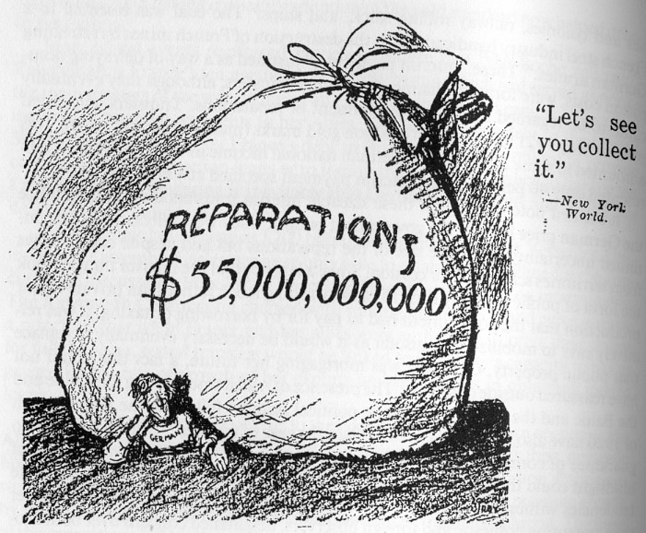(it says “Germany” on the man’s chest)

Scaffolding Questions:
- What does the big bag represent?

- What does the man underneath the bag represent?

- What does the caption “Let’s see you collect it” imply?

Document 5
Hitler’s Speech on the Treaty of Versailles; delivered April 17, 1923
So long as this Treaty stands there can be no resurrection of the German people; no social reform of any kind is possible! The treaty was made in order to bring 20 million Germans to their deaths and to ruin the German nation. But those who made the Treaty cannot set it aside. As its foundation our movement formulated three demands:
- Setting aside of the Peace Treaty
- Unification of all Germans
- Land and Soil to feed our nation
Our movement could formulate these demands since it was not our movement which caused the war, it has not made the Republic, it did not sign the peace treaty.
There is thus one thing which is the first task of this movement: it desires to make the German once more National, that his Fatherland shall stand for him above everything else. It desires to teach our people to understand afresh the truth of the old saying: He who will not be a hammer must be an anvil. An anvil we are today, and that anvil will be beaten until out of the anvil we fashion once more a hammer, a German sword!

Scaffolding Questions:
- What is the intent of the speech?

- What is Hitler’s perspective on the Treaty of Versailles? What statements illustrate his perspective?

- What is Hitler’s perspective on those who agreed to sign the Treaty of Versailles?

- What does he propose in the speech?

Document 6
US National Bureau of Economic Research
Volume Title: German Business Cycles, 1924-1933; publication date: 1934; Chapter 1: The Treaty of Versailles, Inflation and Stabilization
Public opinion in Germany has been inclined to hold the loss of the World War, and the consequent terms of the treaty of peace, as ultimately responsible for all the economic difficulties of the nation since 1918. Thus it was declared in an official memorandum that, because of the Treaty of Versailles, “all of the favorable conditions of the period before the War have disappeared; all the unfavorable conditions have strengthened”...
The loss of European territory, which its attendant losses of sources of industrial raw materials and productive equipment, was serious from the economic viewpoint. The provisions of the Versailles Treaty reduced the 1913 area of Germany by 13.05%. The ceded territories had produced 15.7% of the total value of the German coal output in 1913; 48.2% of the iron ore; 58.8% of the zinc ore; 25.6% of the lead ore…
Self-sufficiency was further limited by the loss of important arable land, about 15.5% of the 1913 area. As the War and the treaty reduced the population by only about 10%, the area available for cultivation was thus relatively, as well as absolutely, smaller than in 1913…
Domestic food production was materially reduced and the necessity for additional importations of foodstuffs correspondingly increased.

Scaffolding Questions:
- What type of document is this?

- What conclusion does the author come to regarding the German perspective of the Treaty of Versailles?

- What specifics does the author provide regarding the economic impact of the Treaty on Germany? What statistics demonstrate that impact?

- What conclusions did the author come to regarding the impact of lost land on Germany’s domestic food production? What statistics show that?

