World War I

Russian Revolution
The Russian Revolution took place in 1917 when the peasants and working class people of Russia revolted against the government of Tsar (King) Nicholas II. They were led by Vladimir Lenin and a group of revolutionaries called the Bolsheviks. The new communist government created the country of the Soviet Union.
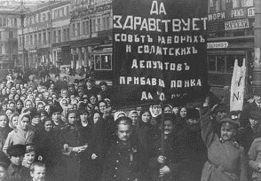
The Russian Tsars
Before the revolution, Russia was ruled by a powerful monarch called the Tsar. The Tsar had total power in Russia. He commanded the army, owned much of the land, and even controlled the church.
During the period of time before the Russian Revolution, life for the working class people and the peasants was very difficult. They worked for little pay, often went without food, and were exposed to dangerous working conditions. The aristocrat class treated the peasants like slaves, giving them few rights under the law and treating them almost like animals.
Bloody Sunday
A major event leading to the Russian Revolution took place on January 22, 1905. A Large number of workers were marching to the Tsar's palace in order to present a petition for better working conditions. They were fired upon by soldiers and many of them were killed or injured. This day is called Bloody Sunday.
Before Bloody Sunday many peasants and working class people revered the Tsar and thought that he was on their side. They blamed their troubles on the government, not on the Tsar. However, after the shootings, the Tsar was perceived as an enemy of the working class and the desire for revolution began to spread.
World War I
In 1914, World War I began and Russia was at war with Germany. A huge Russian army was formed by forcing working class and peasant men to join. Although the Russian army had great numbers, the soldiers were not equipped or trained to fight. Many of them were sent into battle without shoes, food, and even weapons. Over the next three years, nearly 2 million Russian soldiers were killed in battle and nearly another 5 million were wounded. The Russian people blamed the Tsar for entering the war and getting so many of their young men killed.
The February Revolution
The people of Russia first revolted in early 1917. The revolution began when a number of workers decided to strike. Many of these workers got together during the strike to discuss politics. They began to riot. The Tsar, Nicholas II, ordered the army to suppress the riot. However, many of the soldiers refused to fire on the Russian people and the army began to mutiny against the Tsar.
After a few days of riots, the army turned against the Tsar. The Tsar was forced to give up his throne and a new government took over. The government was run by two political parties: the Petrograd Soviet (representing the workers and soldiers) and the Provisional Government (the traditional government without the Tsar).
Bolshevik Revolution
Over the next several months the two sides ruled Russia. One of the main factions of the Petrograd Soviet was a group called the Bolsheviks. They were led by Vladimir Lenin and believed that the new Russian government should be a Marxist (communist) government. In October of 1917, Lenin took full control of the government in what is called the Bolshevik Revolution. Russia was now the first communist country in the world.
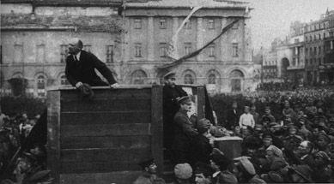
Lenin leading the Bolshevik Revolution
Results
After the revolution, Russia exited World War I by signing a peace treaty with Germany called the Treaty of Brest-Litovsk. The new government took control of all industry and moved the Russian economy from a rural one to an industrial one. It also seized farmland from landholders and distributed it among the peasants. Women were given equal rights to those of men and religion was banned from many aspects of society.
From 1918 to 1920, Russia experienced a civil war between the Bolsheviks (also called the Red Army) and the anti-Bolsheviks (the White Army). The Bolsheviks won and the new country was called the USSR (United Soviet Socialist Republic).
Interesting Facts about the Russian Revolution
- For 303 years the Russian Tsar came from the House of Romanov.
- Although the February Revolution began on March 8 according to our calendar, it was February 23 on the Russian (Julian) calendar.
- Sometimes the Bolshevik Revolution is referred to as the October Revolution.
- The main leaders of the Bolsheviks were Vladimir Lenin, Joseph Stalin, and Leon Trotsky. After Lenin died in 1924, Stalin consolidated power and forced Trotsky out.
- Tsar Nicholas II and his entire family were executed by the Bolsheviks on July 17, 1918.

Name ________________________________________ Date_____________
IT’S YOUR TURN TO SEQUENCE
Identify the events and the date it occurred. Place them in chronological order.

________ _________ __________

________ _________ _________

________ _________ _________

________ _________ _________

