German Propaganda Poster
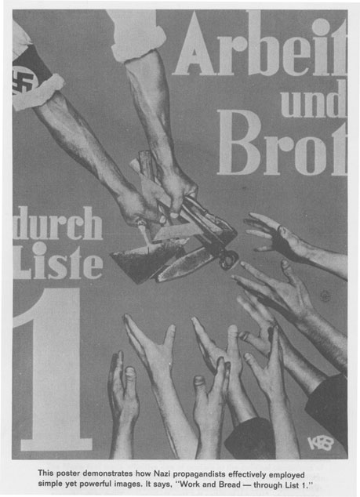
Directions: The following poster translates to “Work and Bread.” Analyze the propaganda poster and answer the following questions below.

- Why was work so important for the German people?

- Why do you think bread was so important to the people?

- Would you follow someone who promised to make your life better even if you thought that their methods were wrong? Why or why not?

